Project 1 - Organizational Employee Dashboard

Define the data model, transform the dataset and create an attractive Power BI Report using the Given Organizational dataset.

Dataset Tables:

Organizational Data
Employee Details
Department and Units
Ethnicity
Country and City

Requirement:
- The Report should contain four Slicers(Department, Unit, Country and City) using dimensional table.
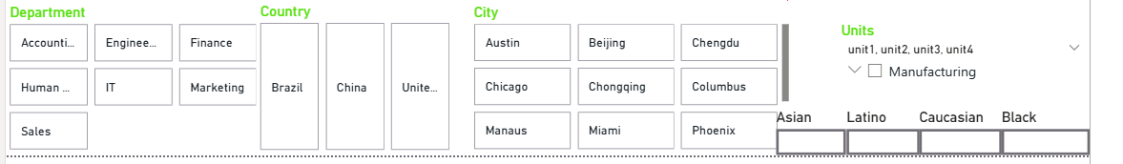

- The Report needs to have two pages(Male and Female)Page1-shows only Male data , Page2-shows only female data.

- The Report should contain 4 visuals
    - Card - Show overall annual salary, Mininum Salary and Maximum salary
    - Bar Chart – Show country and city wise annual salary with drilldown capabilities.
    - Pie Chart – Show Department wise annual salary with filter Employee age should be above 37
    - Matrix – Show the Employee department, unit, country, city, annual salary and bonus (apply conditional formatting Red- if bonus % is 0 and Green- if bonus % is above 0)

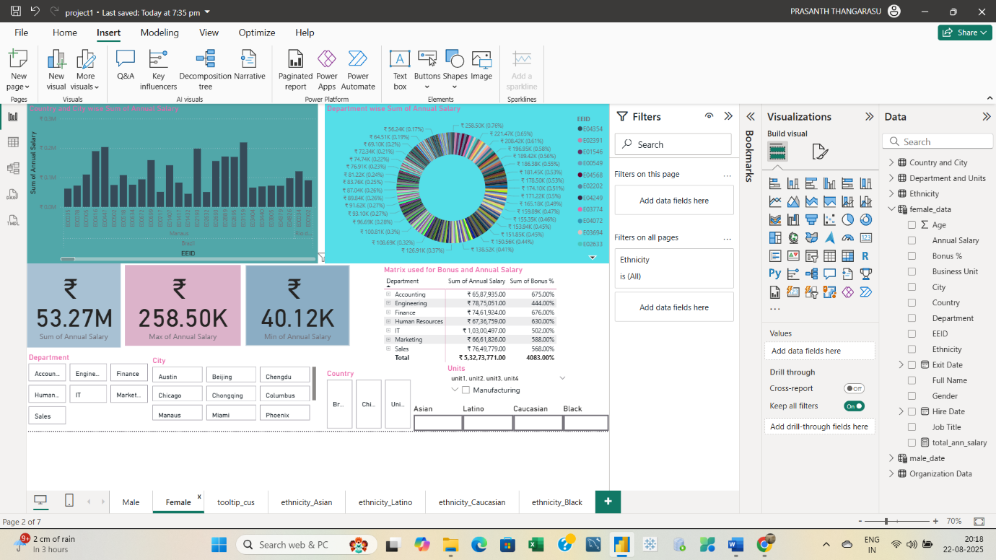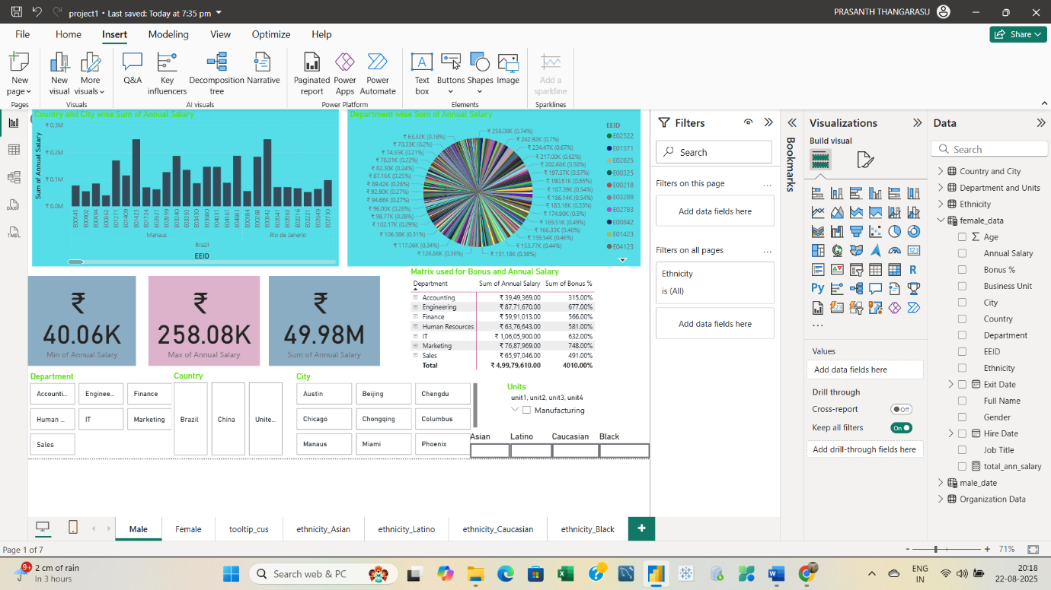

- Create a custom tooltip for any one visual.
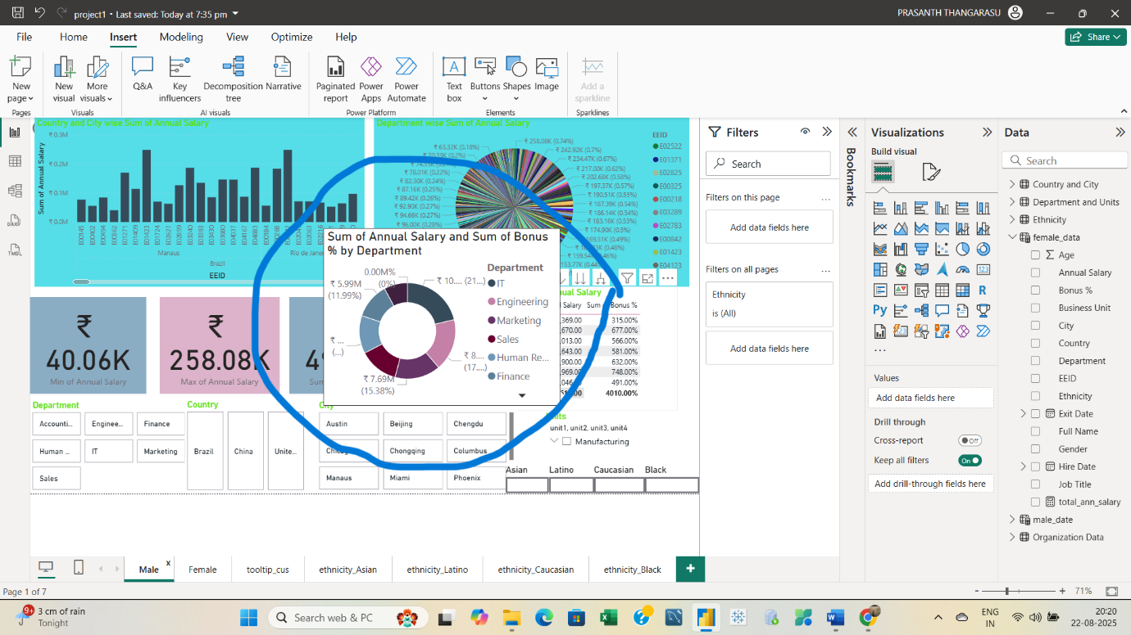

- Create Buttons for each Ethnicity-Bookmark page should be created for each ethnicity
- Each Bookmark page should contain one visual of your choice with any data shown.
- Each Bookmark page should contain a Image to return to main page
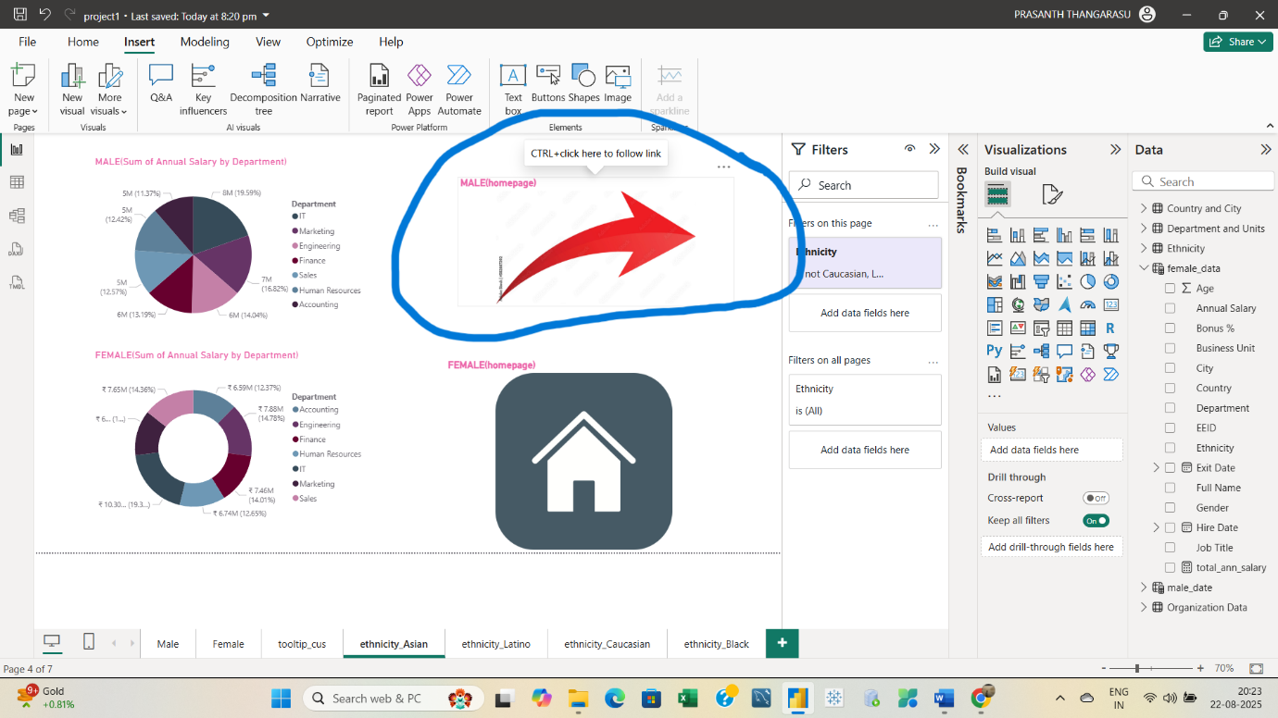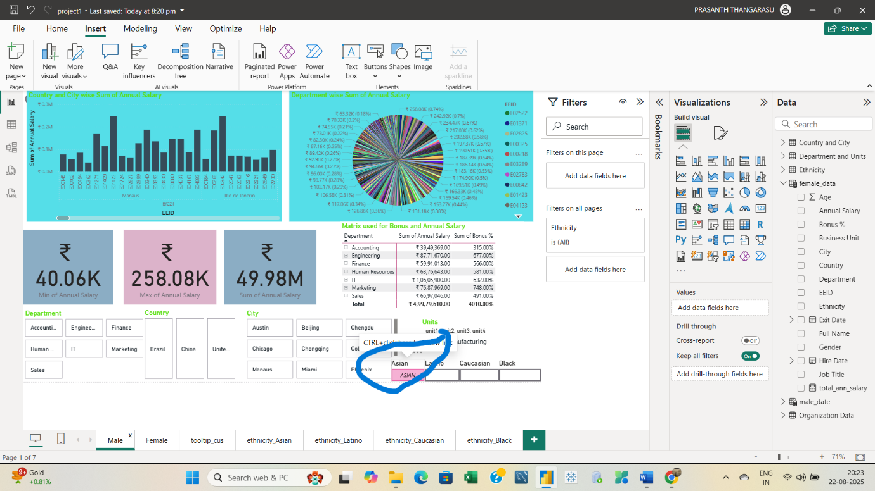

Note:
Identify the right Fact and Dimensional tables, create relationships between the primary and foreign key columns.
Transform the data in the power query editor into needed attributes.
Create Visuals with meaning full Titles and attractive visual level formatting.

